Workflow User Guide

I. Unified Workflow
All Loras use the same workflow. When switching between different Loras, there is no need to modify other models—you only need to complete the following 2 steps:
- Switch Lora: Locate the node numbered #98, then select the corresponding Lora in this node. The recommended Lora weight is between 0.85 and 1.
Lora Modification Node: #98
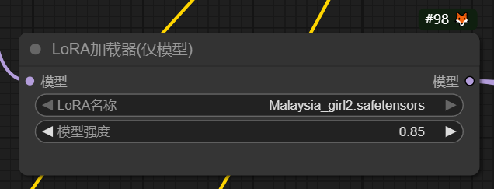
- Modify Prompt: Locate the node numbered #90, then enter the prompt that matches the selected Lora in this node.
Prompt Input Node: #90
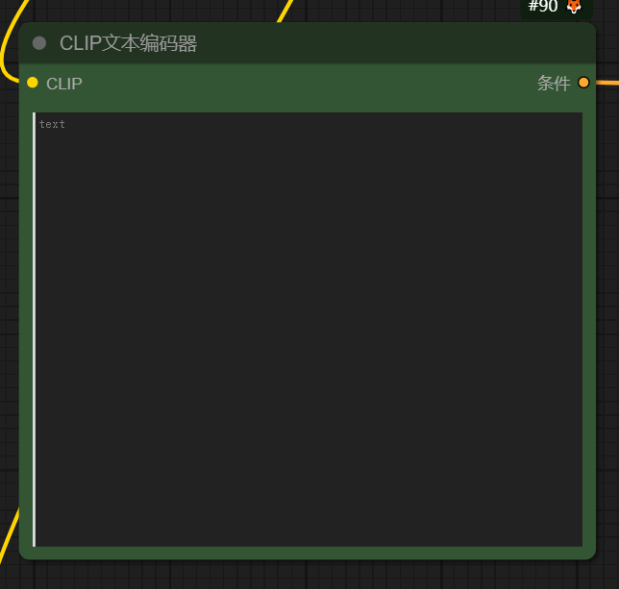

II. Use Lora-Specific Names for Prompts
When using each Lora, please use its designated name. For example:
- For the "Malaysia_girl1" Lora, the character’s designated name is "girl0815". When writing a prompt, you can describe it like this: "A portrait of girl0815, featuring a youthful and enigmatic countenance. Her dark hair, styled in a sleek bob with subtle highlights."
Examples are as follows:

Lora Name | Designated Character Name | Prompt Example
Malaysia_girl1 | girl0815 | A portrait of girl0815, featuring a youthful and enigmatic countenance. Her dark hair, styled in a sleek bob with subtle highlights.
Malaysia_girl2 | Malai1 | A portrait of Malai1, wearing a casual white T-shirt and jeans, with a bright smile.
Malaysia_girl3 | Malai3 | A portrait of Malai3, standing by the window with soft sunlight on her face.

III. Result Selection​
the workflow will generate 2 results . You can compare the two results based on your needs (e.g., image detail, character consistency with the prompt, style accuracy) and select the one that meets your expectations.​
Result Display Area:​
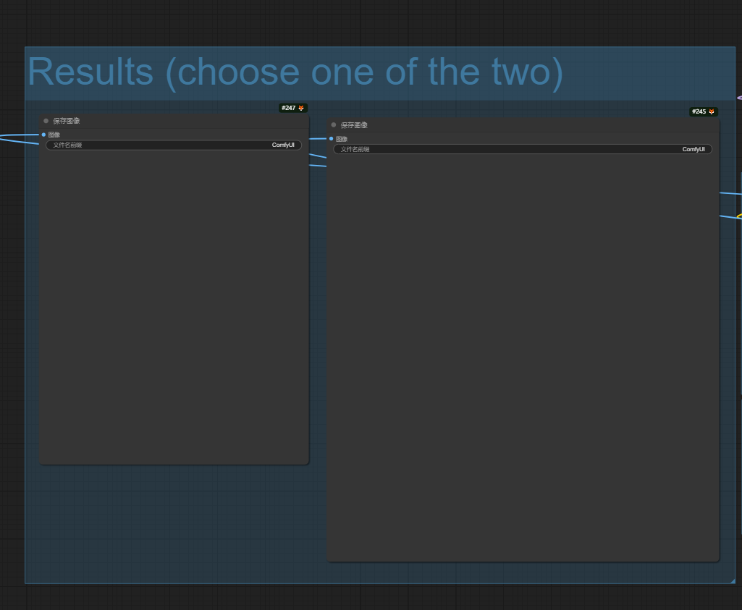
(Note: where the two generated images will be shown side by side for easy comparison.)

